Ideation Phase
Brainstorm & Idea Prioritization Template

Date | 6 July 2026
Team ID | SWTID-2026-4885
Project Name | Automated Employee Onboarding & Off boarding System
Maximum Marks | 4 Marks

Brainstorm & Idea Prioritization Template:
Brainstorming provides a free and open environment that encourages everyone within a team to participate in the creative thinking process that leads to problem solving. Prioritizing volume over value, out-of-the-box ideas are welcome and built upon, and all participants are encouraged to collaborate, helping each other develop a rich amount of creative solutions.
Use this template in your own brainstorming sessions so your team can unleash their imagination and start shaping concepts even if you're not sitting in the same
Step-1:Team Gathering, Collaboration and Select the Problem Statement
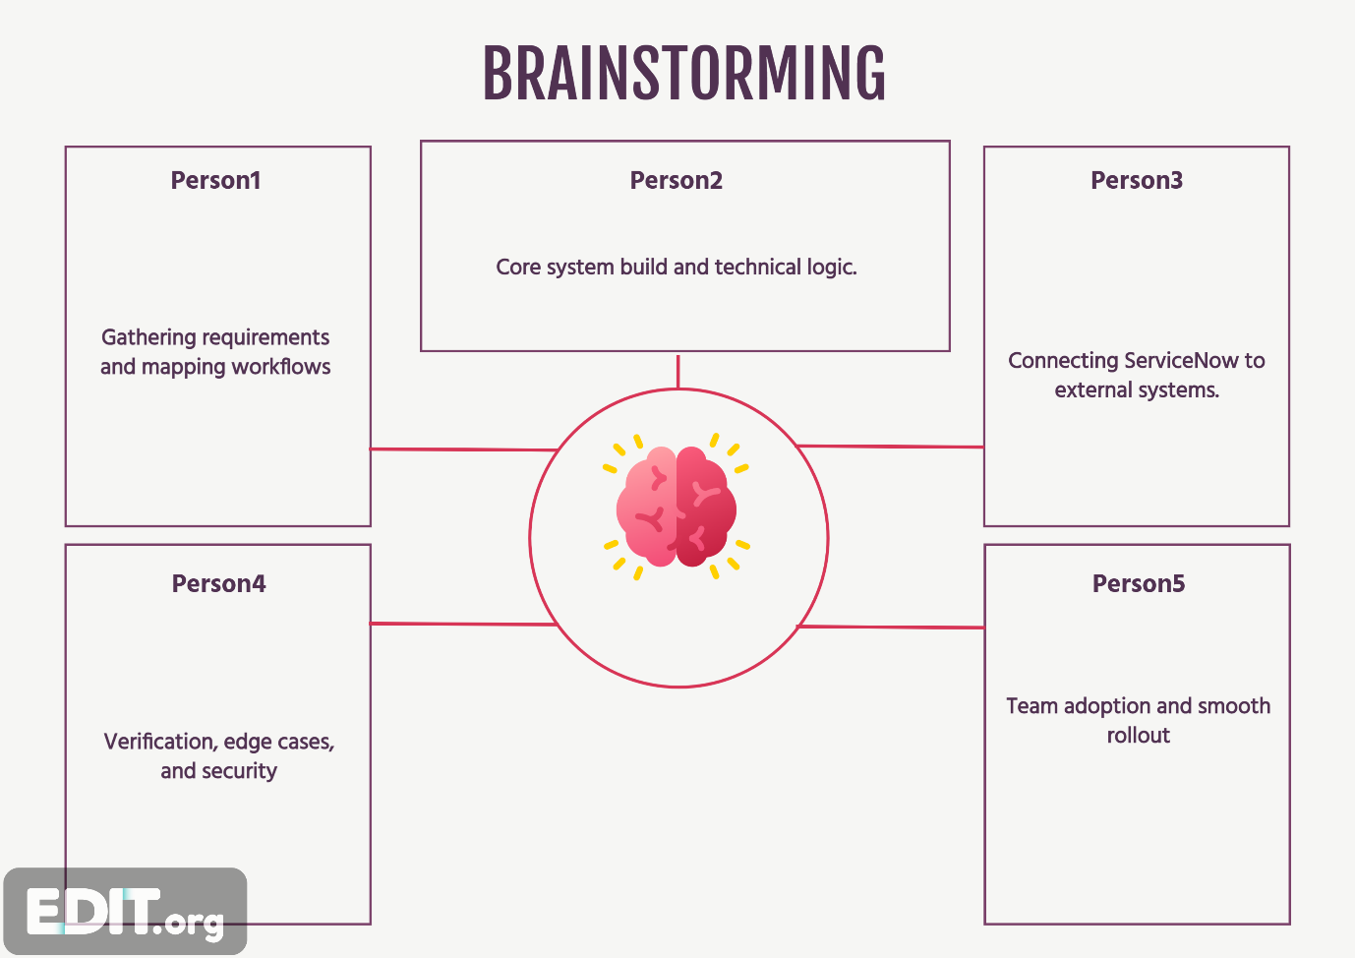

Step 2: Brainstorming, Idea Listing and Grouping
S.No | Idea Description | Category
1 | Automate employee onboarding request process | Workflow Automation
2 | Automate employee offboarding process | Workflow Automation
3 | Create Service Catalog items for onboarding and offboarding | Service Catalog
4 | Generate automatic tasks for HR, IT, Facilities and Security | Task Automation
5 | Configure approval workflows using Flow Designer | Approval Management
6 | Implement role-based ACLs for secure access | Security
7 | Configure SLA monitoring for task completion | SLA Management
8 | Send automatic email notifications | Notification System
9 | Design HR dashboards and reports | Dashboard & Reporting
10 | Track employee lifecycle status in real time | Employee Tracking
11 | Test complete onboarding/offboarding workflow | Testing
12 | Improve compliance using audit trails | Compliance

